ESB(Enterprise Service Bus) is an example of Mediator Pattern

A chat room could use the Mediator pattern. UserA, UserB, UserC, all wants to communicate. Facebook would be the perfect example of practical Mediator pattern.

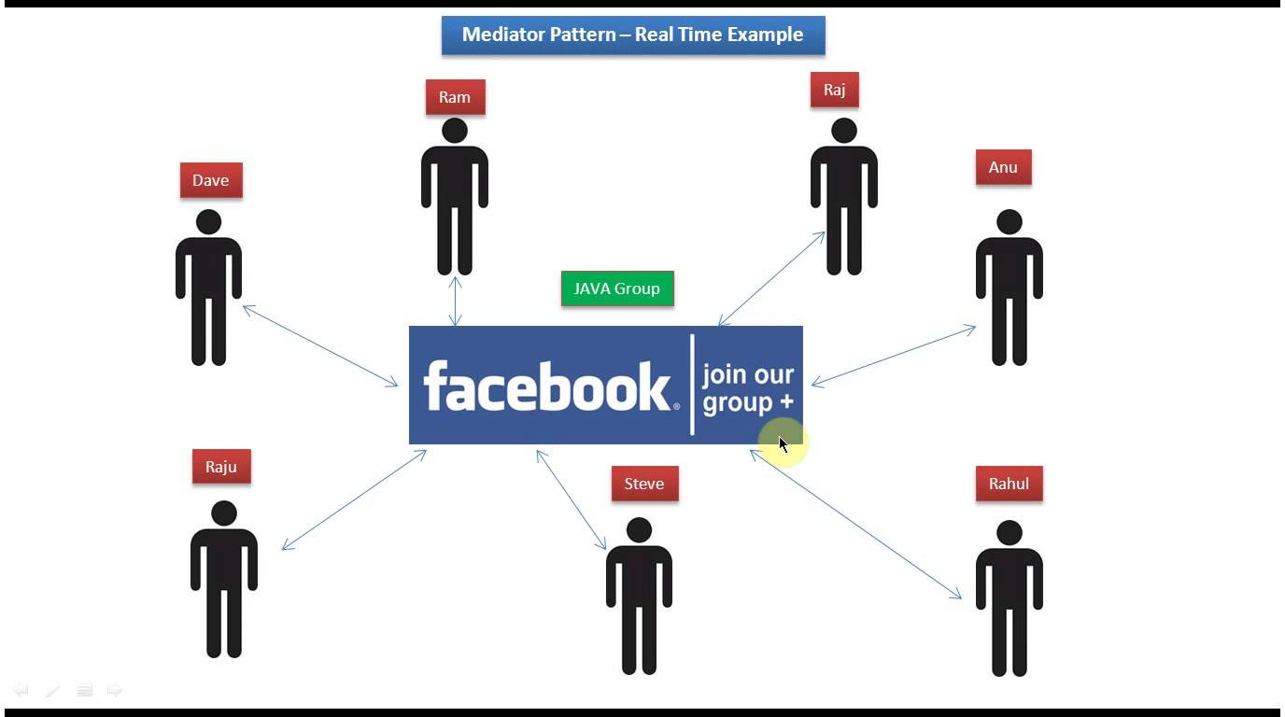

Mediator enables decoupling of objects by introducing a layer in between so that the interaction between objects happen via the layer.

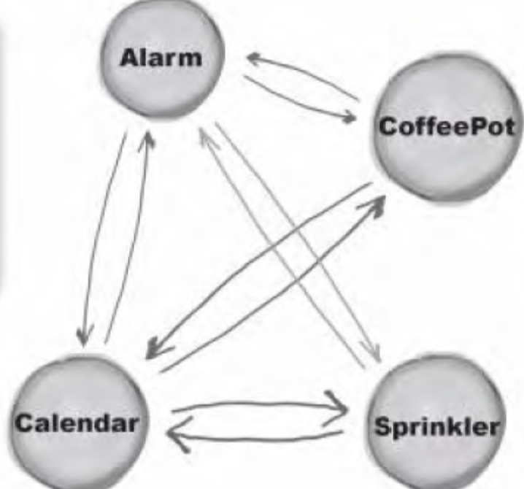

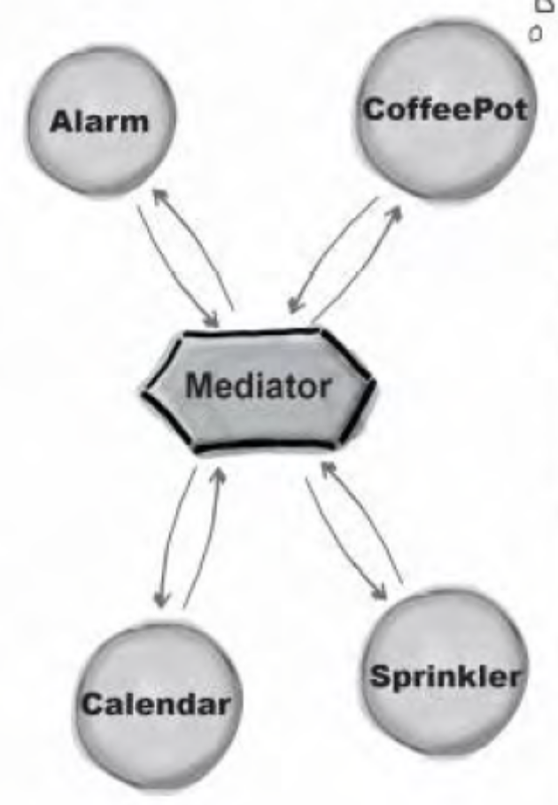

Mediator Pattern Implementation
In a mediator design pattern implementation we will have
- mediator interface – an interface that defines the communication rules between objects
- concrete mediator – a mediator object which will enables communication between participating objects

